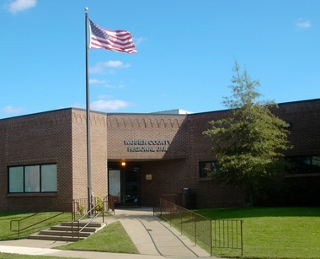
Warren County Regional Jail
920 Kentucky St
Bowling Green, Ky 42101

Introduction_____________________________
Thank you for considering Warren County Regional Jail as an employment opportunity. We have designed this brochure as a brief reference guide as to what you can expect if you choose to move forward in a career in the correctional officer field. This brochure contains information that includes but not limited to.
- Brief History
- Rank Structure
- Pay and Benefits
- Work Hours
- Deputy Jailer Job Expectations
- Positive/Negative Aspects Of Your Job
- Successful Deputy Characteristics

Brief History________________________________
- The main jail was completed in April of 1987. When it was opened 78 inmates were moved from the old jail located at 429 East 10th St.
- In 1998 we opened the 144 bed Class D building which houses work release inmates and inmates who are on the Class D program. In 2000 we opened another 160 bed addition which houses the females and Federal inmates.
Shifts Hours: 8
1st shift 7 a.m. until 3 p.m.
2nd shift 3 p.m. until 11 p.m.
3rd shift 11 p.m. until 7 a.m.
5 day work week 40 hours total
Weekend shift Hours: 16
Sat. & Sun. 7 a.m. until 11 p.m.
1 additional 8 hours day during the week
40 hours total
4 days off work

- In 2003 our old juvenile section of the facility was transformed into a female Class D program. It was recently renovated again allowing for an additional 12 inmates.
- There has been a change in the Kentucky Jail Standards which has allowed us to add additional beds in selected cells which brings our total beds to 562.
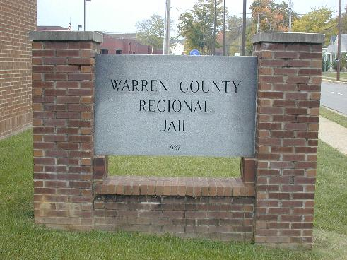
Contact us: (270) 843-4606 ext. 112
Or Visit us At: www.warrencountyjail.com

Pay and Benefits_____________________
Warren County Regional Jail believes our pay scale and benefits package is equal to many surrounding agencies.
- Pay increase every July
- $450.00 monthly for health insurance
- 1 sick day accumulated each month
- 1 vacation day accumulated each month
- 30 year county retirement system
- $10,000 life insurance policy
- Extra pay for overtime and holidays
- Opportunities for deputies to be promoted in the chain of command

Work Hours/Shifts__________________
Warren County Regional Jail employees are guaranteed a 40 hour work week with extra pay options for overtime/holidays. The jail offers opportunities to work hours better suited to your life style. The following are examples of available shifts
Deputy Jailer’s Responsibilities______________
A Deputy Jailer’s main responsibility is for the custody, safety, security and supervision of the incarcerated individuals of the jail. While every shift may vary in required responsibilities; the following is a brief overview of daily responsibilities.

- Intake and release procedures of prisoners
- Searches; including but not limited to: Cell searches, Pat down searches & Strip searches
- Escorting Prisoners; including but not limited to: Court, Recreation, Medical Office, Dentist and Visitation
- Supervision of inmates in the Pod Areas/housing units
- (View the interior of the jail at www.warrencountyjail.com)
- Transportation of prisoners to other facilities
- Class-D work Program
- Booking Officer: A deputy trained/ designated to enter a prisoners charges and biographical information is entered into the computer system.

Positive Aspects of Job_____________
- Contribution to Society
- On job training
- Dependable coworkers
- Face different situations
- Evenly dispersed workload
- Excellent learning Opportunity
- Teamwork experience

Negative Aspects of Job____________
- Stress caused from individuals around you including but not limited to: inmates, public & coworkers
- Conflicts with inmates
- Requires teamwork

Characteristics of a Successful Deputy
In order to be a successful deputy jailer there are a certain number of characteristics you need to possess. These characteristics include the following.
- Awareness of surroundings
- Ability to take criticism
- Good Communication skills
- Ability to stay calm under pressure
- Positive attitude
- Ability to follow the rules
- Sense of Humor
- Ability to take control of situations

Chain of Command__________________
In a business organization, the chain of command refers to levels of authority in the company from the top position, such as a CEO or business owner, down to workers on the front line. The Warren County Regional Jail institute a chain of command to provide workers at all levels with a supervisor to whom they may ask questions or report problems. The following is the established Warren County Regional Jail’s Chain of Command:

- Jailer: An elective official in charge of the jail and prisoners confined in it.
- Chief Deputy: The chief deputy jailer ensures the department/county policies are followed and acts as the department head in the absence of the jailer.
- Captain/Supervisor: A person who supervises/directs the workers or work done by others in the jail.
- Lieutenant/Assistant Supervisor: A person who assist the supervisor with jail operations.
- Sergeant: A person who trains and guides deputy jailers in jail operations.
- Deputy Jailer: A person who is responsible for the custody, safety, security, and supervision of inmates in a prison or any other correctional facility.

Conclusion___________________________

We hope that this brochure has given you a better understanding of the job of deputy jailer. We hope you are still interested in this position. For whatever reason, if you no longer feel like this is the job for you, we understand. We want you to make this decision based on as much information as possible in hopes of producing the most beneficial outcome for you and the Warren County Regional Jail. If you need more time to think about your decision that is fine as well. We appreciate your time and attention to this material, and we hope you find it useful.

Additional Information________________________
For additional information please contact:

Stephen Harmon

920 Kentucky St. Bowling Green, Ky 42101

(270) 843-4606 Ext. 112 or Stephen.Harmon@ky.gov

Visit our website www.warrencountyjail.com

